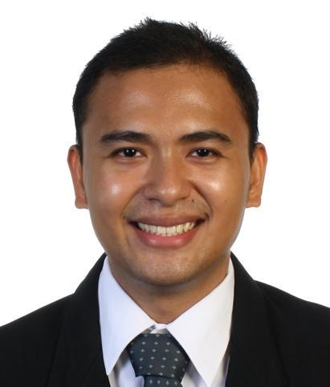
Aldwin Joseph Pablo Tabasa
4-P E. Sabellano Street, Punta Princesa
Cebu City, Cebu 6000
(032) 414-3011
+63916-704-4810
dwinster@yahoo.com.ph

Highlights

Able to communicate positively with staff
Possess excellent English communication and interpersonal skills
Hardworking, independent, and highly motivated
Willing to learn new and complex tasks

Personal Data

Date of Birth : August 7, 1987
Age : 26
Gender : Male
Height : 5’ 4 ½”
Weight : 130 lbs
Religion : Roman Catholic
Civil Status : Single
Citizenship : Filipino

Educational Background

Tertiary Bachelor of Arts in Linguistics & Literature
University of San Carlos – Technological Center
Gov. M. Cuenco Ave., Nasipit, Talamban, Cebu City
June 2008 – October 2010

Bachelor of Science in Applied Physics
University of San Carlos – Technological Center
Gov. M. Cuenco Ave., Nasipit, Talamban, Cebu City
June 2004 - March2008

Secondary Cebu Institute of Technology
Natalio Bacalso Avenue, Mambaling, Cebu City
June 2000 - March 2004

Primary Punta Princesa Elementary School
Tres de Abril Street, Punta Princesa, Cebu City
June 1996 - March2000

Cebu Normal University
Osmeña Boulevard, Cebu City
June 1994 - March 1996

Honors and Achievements

Spelling Contest 3rd Place
Cebu Schools Athletic Foundation Incorporated (CESAFI)
Cebu Coliseum, Sanciangko Street, Cebu City
February 4, 2010

Dean’s Lister 2nd Semester School Year 2008-2009
1st Semester School Year 2009-2010
2nd Semester School Year 2009-2010

Employment History

Employer | Details
None | Position: Freelance Editor and Writer  Job Description: 1. I research materials based on the topic assigned by the client.  2. I write articles based on the information gathered through research.  3. I proofread and edit literature written by clients to ensure grammar rules are followed.  4. I document sources by following APA referencing.  Date of Employment: March 2013 – Present
Accenture, Incorporated  (Cebu City, Philippines) | Position: Program Control Services  Job Description: Provides administrative support to projects such as making room reservation for meeting spaces, processing food requests, facilitating IT-related requests & making follow-ups, and consolidating pay premiums and weekly reports.  Date of Employment: June 2012 – March 2013
Convergys Philippines Services Corporation (Cebu City, Philippines) | Position: Sales and Support Representative  Job Description: Provide solutions to customer issues such as slow internet connection and no dial tone; installation of web browsers and anti-virus software; provisioning of internet and phone signals to the modem; and password reset for customer’s emails through chat.  Date of Employment: January 2011 – January 2012

Skills
Operation of Microsoft Office Applications such as Word, Excel, and Powerpoint; business correspondence such as writing letters, reports, and essays

Interests
Reading journals and news, surfing the internet, and traveling

Affiliations
Name of Organization | Details
Fidelis Choir | We sing songs during Mass every Saturday evening and every 1st and 3rd Sunday of the month. We also sing during weddings.

References
Name | Company/Institution | Contact Number
Charity Tecson, Ph.D. | University of San Carlos | +63917-546-8690
Cristie Ann Delfin, Ph.D. | University of San Carlos | +63927-714-0571
Rachelle Blanche Bautista | Convergys | +63932-884-2009
Eddil Cañete | Fidelis Choir | +63922-513-8040
Tracy Trinidad | Private Tutor | +63923-845-7347
Roald Reyes | Accenture | +63917-555-8811

